Oscilloscopes and Circuits

NE 401/550

**Introduction:**

An oscilloscope is one of the most powerful inspection equipment in the laboratory. Oscilloscopes are able to capture and analyze various analog and digital signals, enabling the diagnostic analysis of various electronic system components and signals. In the nuclear instrumentation laboratory, the oscilloscope will provide the means to inspect the signal coming from the detector, preamplifier, amplifier, discriminator, and many other modules not covered in this class.

**Oscilloscope Basic Functions**

The oscilloscope has several controls on its front panel. In the associated laboratory with this document, students will be introduced to the basic functions of the oscilloscope. In the image below, the oscilloscope that is in the student laboratory is provided. There are several color boxes on the oscilloscope (blue, black, red, yellow, and green). A discussion of each of these boxes is provided below.

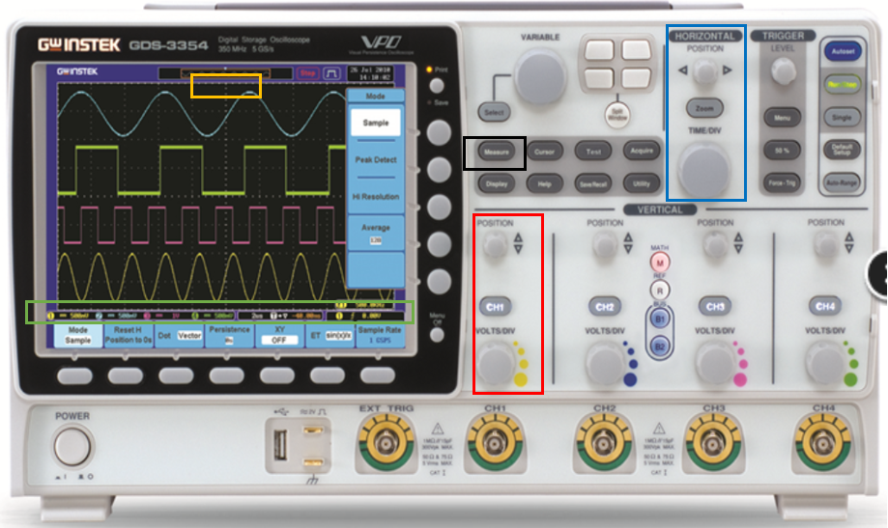

**The Screen:** The screen has all of the user-relevant information on it. There are a series of graticules on the screen, where each major graticule line is equal to the time (x) or voltage (y) division. The minor graticule marks are each one-fifth of the time (x) or voltage (y).

**Blue box:** The blue box controls the time axis. The adjustable knob controls the position of the center of the triggered trace, where the trigger center point is defined where the trace passes the trigger. The trigger is defined as a voltage level that, when the input signal passes this level, it is displayed on the screen. The image of the oscilloscope provided has a **yellow box** around where the intersection of the trace and center of the time scale is when it is centered on the screen, identified by an upside down yellow triangle. Note, however, that the yellow triangle need not be centered, nor even visible on the screen. This is a common issue students have when using the oscilloscope, where the features of the trace are off the screen, and students theorize something is wrong with the system, when it in fact it is user error with the oscilloscope.

Also within the **blue box** is the time division knob, which controls the time division settings per major graticule along the horizontal axis.

**Green box:** The green box displays many functions and settings of the oscilloscope and changes pending what the user is trying to do. The box itself is highlighting on-screen measurements, just above the blue colored on-screen items. Each measurement shown on-screen identifies the measurement type and the channel corresponding to that measurement. The buttons below the screen control the functions in the blue colored-area at the very bottom of the screen. The functions vary based upon user input, but typically they correspond to individual channels and are activated by pressing the “channel” button, as seen in the **red box**. Of most importance,

**Red box:** The red box just highlights one of four different identical controls adjacent to each other, differing only in the input channel they correspond to. There are four input channels to the oscilloscope. The large variable knob just above the BNC connector controls the voltage division between each major graticule and ranges from 2 mV to 5 V (may vary by model). Above this knob is the channel button. Pressing this button will turn on and off acquisition of this channel as well as activate the on-screen controls with the buttons at the bottom of the screen just discussed. Above that is the position knob, which controls the position of the trace along the y-axis. This has value in moving traces from different channels away from each other for inspection (i.e., so they do not overlap).

**Black box:** As previously noted for the green box, users can set up various measurements for each channel. Pressing the measurement button will open up a series of options in blue on the right side of the screen. Users can choose the channel and measurement type from this menu. Also within this array of buttons is the utilities button, which students will use to choose the directory and enable the ability to save traces (screen shots or data sets) of traces.

What has been presented is just the very basics of the oscilloscope, and its measurement capabilities far exceed what has been presented here. A complete listing of the functions of the oscilloscopes available in the teaching laboratory can be found within its manual.